**Overdose Deaths vs. Poverty Rate**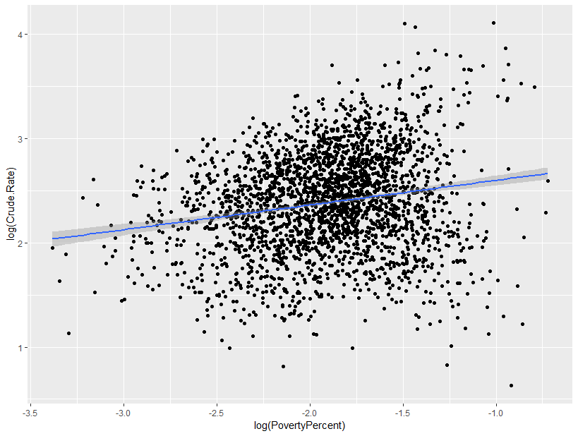

Call:

**log(Crude.Rate) vs. log(PovertyPercent)**

Residuals:

Min 1Q Median 3Q Max

-1.98951 -0.31206 0.01777 0.33909 1.61627

Coefficients:

Estimate Std. Error t value Pr(>|t|)

(Intercept) 2.83669 0.04654 60.951 <2e-16 ***

log(PovertyPercent) 0.23661 0.02393 9.889 <2e-16 ***

---

Signif. codes: 0 ‘***’ 0.001 ‘**’ 0.01 ‘*’ 0.05 ‘.’ 0.1 ‘ ’ 1

Residual standard error: 0.4742 on 2598 degrees of freedom

Multiple R-squared: 0.03627, Adjusted R-squared: 0.0359

F-statistic: 97.79 on 1 and 2598 DF, **p-value: < 2.2e-16**

**Overdose Deaths vs. Poverty 18U**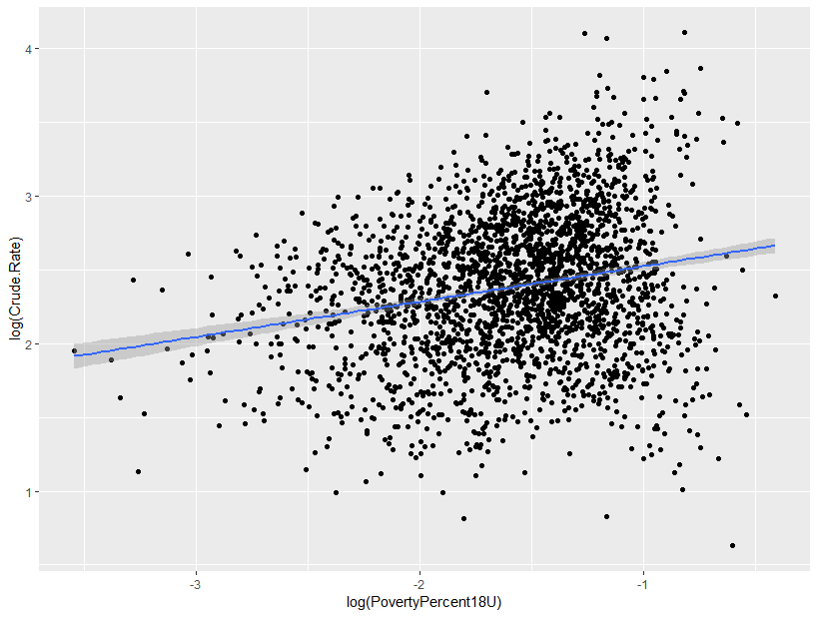

Call:

lm(formula = log(Crude.Rate) ~ log(PovertyPercent18U))

Residuals:

Min 1Q Median 3Q Max

-1.99019 -0.31481 0.01302 0.33708 1.63887

Coefficients:

Estimate Std. Error t value Pr(>|t|)

(Intercept) 2.76439 0.03472 79.61 <2e-16 ***

log(PovertyPercent18U) 0.23951 0.02117 11.31 <2e-16 ***

---

Signif. codes: 0 ‘***’ 0.001 ‘**’ 0.01 ‘*’ 0.05 ‘.’ 0.1 ‘ ’ 1

Residual standard error: 0.4716 on 2598 degrees of freedom

Multiple R-squared: 0.04695, Adjusted R-squared: 0.04659

F-statistic: 128 on 1 and 2598 DF, **p-value: < 2.2e-16**